Xidian University & Heriot-Watt University

**Photoelectric Effect**

(Lab 2)

Semiconductor Electronics

Xunchi Ma

21012100015

2023-11-08

**1.Aims and Objectives**

The photoelectric effect serves as a means to ascertain Planck's constant (h). Initially discovered in 1887 by Heinrich Hertz, the photoelectric effect was observed when a spark more readily leapt between two electrified spheres upon their illumination by light from another spark. In 1905, Einstein offered an elucidation of this phenomenon, employing quantum mechanics principles earlier introduced by Planck, aligning experimental findings with theoretical expectations.

In this experiment, light from a conventional light bulb is channeled onto a potassium photocell's surface, passing through assorted color filters. The ensuing photoelectric current is curtailed by administering a stopping potential. The requisite stopping potential, in relation to the spectral line's wavelength, facilitates the computation of Planck's constant.

1. **Background Theory**

In the photoelectric experiment, a cessation of the photoelectric current (I=0) is observed when the stopping potential applied is sufficient to hinder the most energetic photoelectrons emitted from the cathode from arriving at the anode. This stopping potential, V_0 , when multiplied by the elementary charge (e), represents the elevation in the potential energy of the electrons. Consequently, the multiplication of the stopping potential and the electronic charge equates to the reduction in kinetic energy of the photoelectrons.

$$eV_{0}=\frac{1}{2}mv_{Max}^{2}$$

In the context of photoelectric emission, the variables e, V_0, m, and v denote the electronic charge, stopping potential, electron mass, and velocity of the ejected electron, respectively. The kinetic energy imparted to the electrons is sourced from the energy of incident photons, which is quantified by hf. However, the kinetic energy of the electrons does not match the entire energy of the photons, represented by hf, due to the work function ϕ. The work function is the requisite energy for the electrons to overcome the material's surface potential barrier inherent to the photoelectric cathode layer.

Consequently, the relationship that follows is established:

$$hf=ϕ+\frac{1}{2}mv^{2}=ϕ+eV_{0}$$

By rearranging this equation we obtain:

$$V_{0}=\frac{h}{e}f−\frac{ϕ}{e}$$

It represents a straight line of slope *h/e* if it is assumed that *ϕ* is a constant

When a graph of Vo against f is constructed, the slope of the most accurate straight line through the plotted points can be determined. By multiplying this slope by the electron charge (e), a value for h can be deduced, without requiring any prior knowledge of the work function (ϕ) value. Typically, the work function for many metals ranges between 2 to 5 electron-volts, and for certain metals like potassium (ϕ = 2.2 eV), the photoelectric threshold falls within the visible spectrum.

1. **Experimental Equipment**

Photoelectric Instrument

- mercury lamp and power supply

- photoelectric tube

Control Unit

- current display & range control

- voltage display & control

5 filters of various frequency of transmission

3 photocell covers with apertures of various diameters

Light cap

Photocell cap

Connection cables

1. **Experimental Procedure**

The experimental procedure is bifurcated into two segments. The initial segment involves the determination of the negative stopping potential necessary to nullify the photocurrent, employing the "Cut-off Voltage" function of the Control Unit. Subsequently, in the second segment, the photocurrent is gauged under differing conditions utilizing the "V-I Characteristic Test" feature of the Control Unit. Notably, the labels for these modes are inscribed in Chinese on the Control Unit, and the unit is equipped with a button to switch between these functions.

A. Measurement of Stopping Potential

Initiate the experiment by powering the mercury lamp, shielding it along with the photoelectric apparatus with their respective caps, and allowing a warm-up period of 20 minutes. Activate the "Cut-off Voltage" setting on the Control Unit. Select the current range of 10-13 A and utilize the adjustment knob to calibrate the current reading to zero. Establish a 40 cm distance between the filter on the photoelectric device and the mercury lamp. Employ the connection cables to link the Photoelectric Instrument and the Control Unit, matching the colors (red to red, blue to blue).

Proceed to uncover the mercury lamp cautiously. Position the cap with a 4 mm opening before the photocell on the Photoelectric Instrument. Insert the 365.0 nm filter into its holder on the device.

Monitor the voltage and the corresponding current displayed on the Control Unit. Utilize the arrow keys to modify the voltage, aiming to diminish the current down to zero. Document the voltage that achieves the suppression of the photocurrent, identified as the stopping potential V_0. Tabulate your findings, noting the filter utilized and providing suitable headings for the measurements and units. Execute this method twice more, facilitating the calculation of an average from three results during analysis.

Subsequent to this, replicate the entire process for each filter, recording the outcomes in the table. Ensure the lamp is covered during the filter exchanges.

B. Investigation of the Photoelectric Current-Voltage Characteristics

Switch the Control Unit to the "V-I Characteristic Test" mode. Disconnect the Photoelectric Instrument from the Control Unit. Alter the current range on the Control Unit to the 10-11 A range, reset the current display to zero, and reconnect to the Photoelectric Instrument. Maintain the 40 cm distance between the lamp and filter, and position the 435.8 nm filter in the holder.

Increment the voltage in 5 V intervals from 10 to 50 V, documenting the resulting photocurrent at each increment in a table, ensuring three sets of measurements per voltage. Replicate this step utilizing the 546.1 nm filter.

Adjust the voltage to 30 V and modify the aperture diameter in 2 mm increments from 2 to 8 mm, which modulates the light intensity impinging on the photocell. Record the corresponding photocurrent for each light intensity with the 435.8 nm filter and note the results in a table, with three sets of measurements for each aperture size. Execute the same procedure with the 546.1 nm filter.

Finally, with the voltage set at 30V and the aperture at 8 mm, decrease the distance between the lamp and the filter on the photoelectric device in 20 mm steps, from 400 mm to 320 mm, using the 435.8 nm filter. This alteration lessens the luminous flux reaching the photocell. Measure and log the photocurrent for each proximity in a table, and again, perform three sets of measurements for each distance. Repeat these steps with the 546.1 nm filter.

1. **Results**

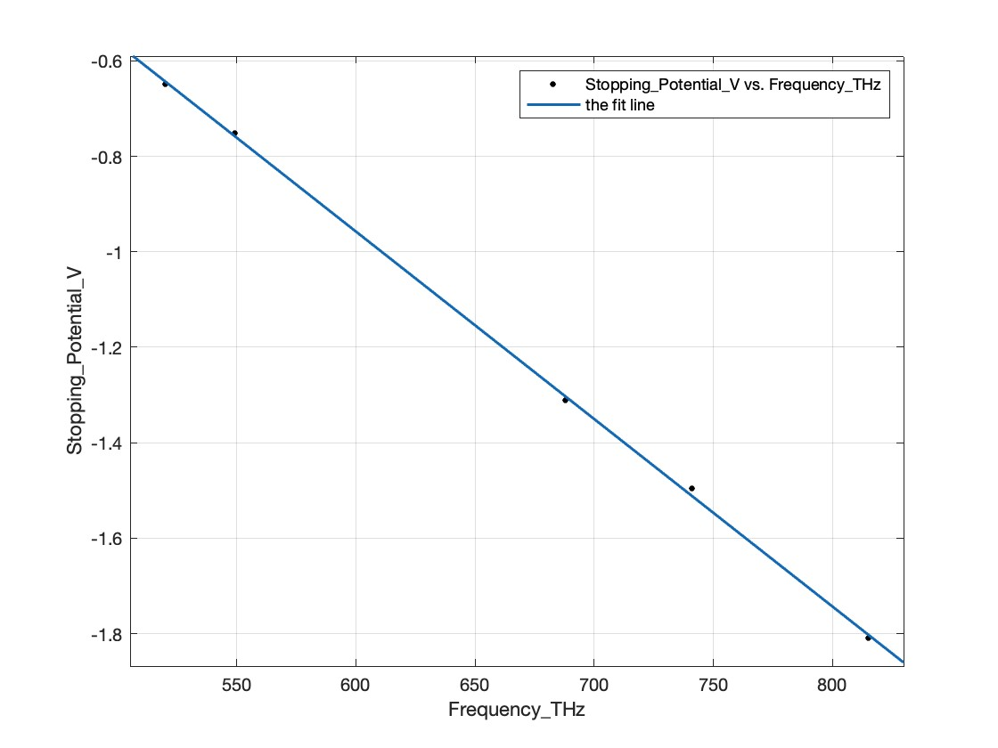

Figure-1 Stop Voltage vs. Frequency

Table-1 Stop Voltage Measurement Results

|  |  |  |  |  |  |
| --- | --- | --- | --- | --- | --- |
| Wavelength | 365nm | 405nm | 436nm | 546nm | 577nm |
| Frequency | 815THz | 741THz | 688THz | 549THz | 520THz |
| Stopping Potential | -1.81V | -1.496V | -1.312V | -0.752V | -0.648V |

$$h=e×\frac{V_{2}−V_{1}}{f_{2}−f_{2}}=6.2478×{10}^{−34} J∙s$$

$$h_{0}=6.626×{10}^{−34} J∙s$$

$$E_{rr}=\frac{h−h_{0}}{h_{0}}=−0.0571$$

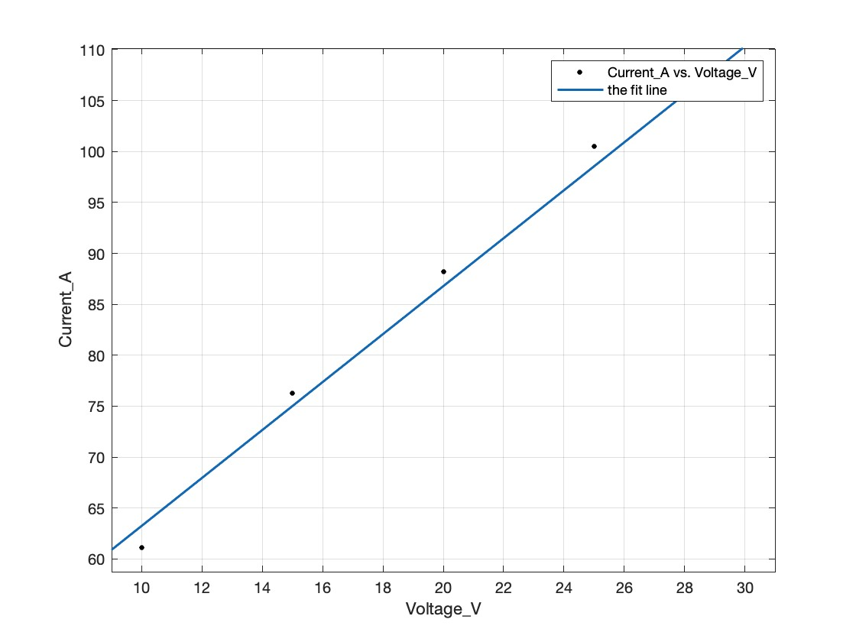

Figure-1.1 current against applied voltage(435.8mm, 4mm, 40cm, A*10^-11)

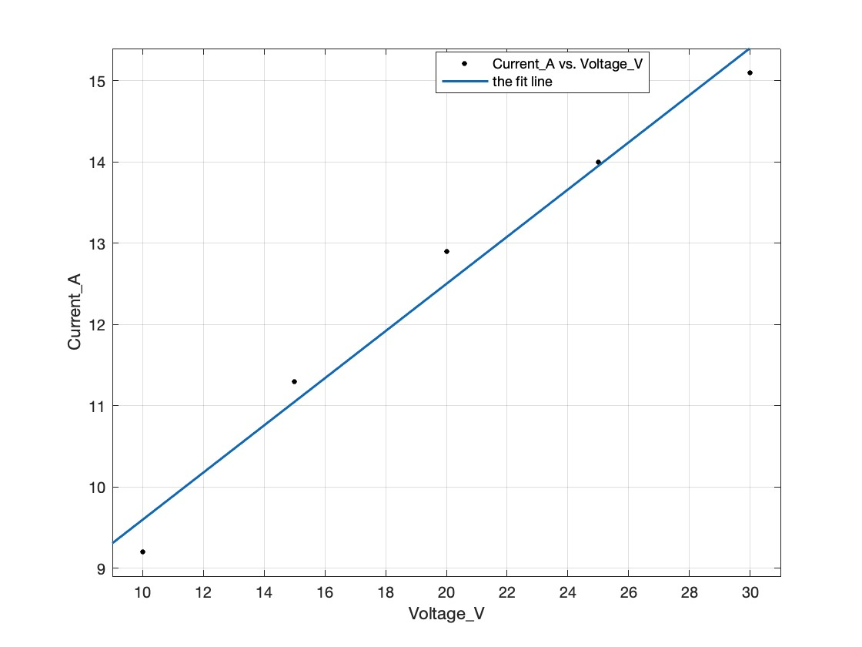

Figure-1.2 current against applied voltage(546.1mm, 4mm, 40cm, A*10^-11)

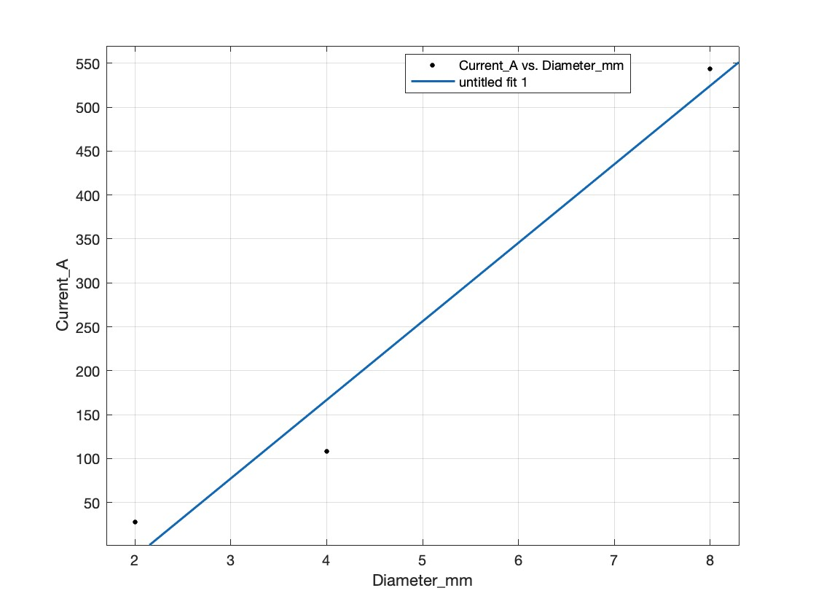

Figure-2.1 current against aperture diameter(435.8mm, 30V, 40cm, A*10^-11)

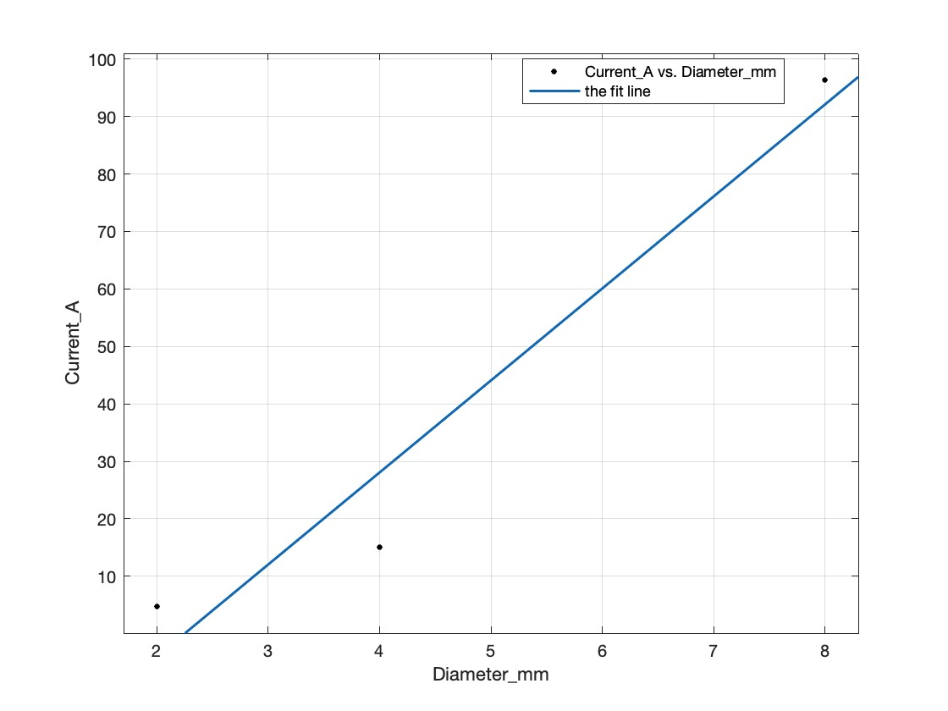

Figure-2.2 current against aperture diameter(546.1mm, 30V, 40cm, A*10^-11)

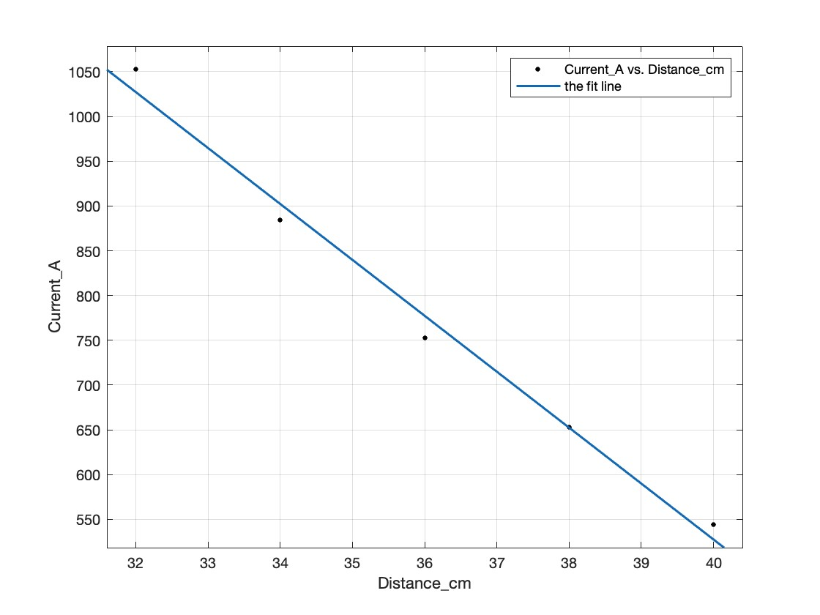

Figure-3.1 current against lamp distance(435.8mm, 30V, 8mm, A*10^-11)

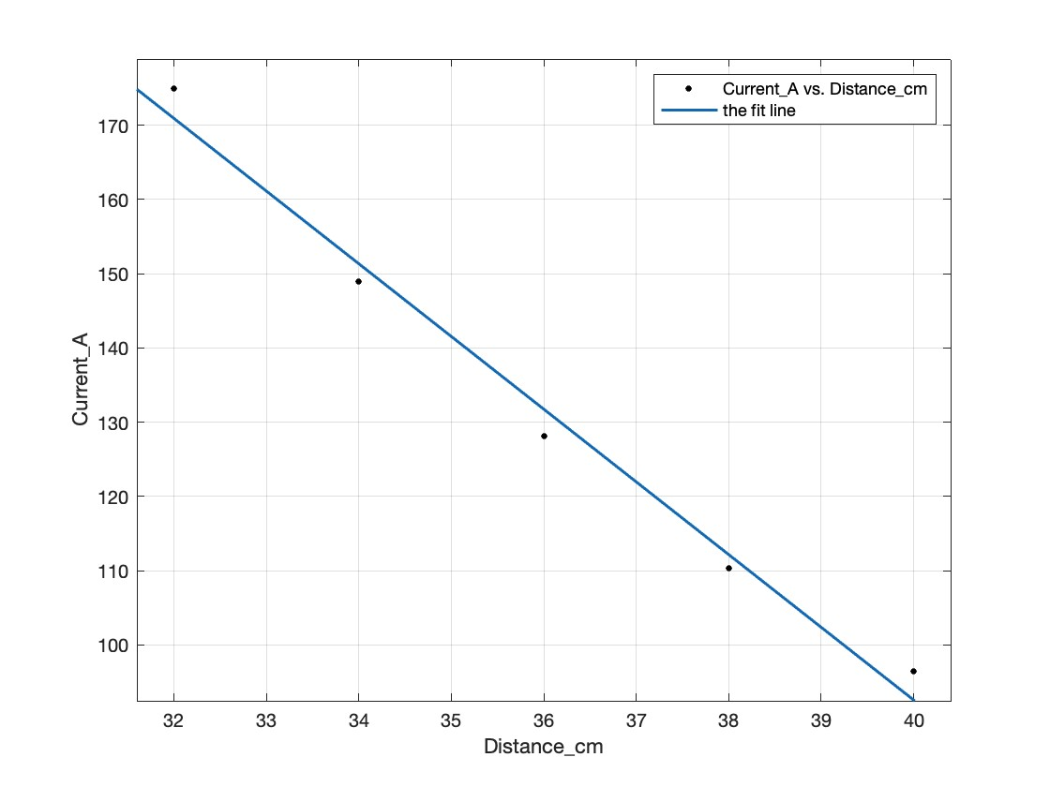

Figure-3.2 current against lamp distance(546mm, 30V, 8mm, A*10^-11)

**6.Analysis and Discussion of Results**

All the results approximately aline on a straight line which indcates that the accuracy of the results is relatively high. In order to further improve it we need to:

* Enhance Calibration:

Ensure all instruments are properly calibrated before the experiment begins. For example, verify the wavelength of light filters and the accuracy of the voltage and current measurements.

* Enhance environmental Control:

Conduct the experiment in a dark room to minimize the effect of ambient light on the photoelectric effect.

Control temperature as it can affect the sensitivity of the photocell and the behavior of the electrons.

What properties of the light beam determine at which value of the voltage the

photoelectric current will be suppressed to zero?

**the frequency**

Approximately what value of voltage will be required to suppress the photoelectric

current due to X-rays with a wavelength of 1 nm and gamma rays with a wavelength of 1 pm? Comment on your calculated values.

**solution:**

$$V_{0X}=\frac{E_{x}}{e}=\frac{h_{0}\frac{c}{λ}}{e}=1241V$$

$$V_{0gamma}=\frac{E_{x}}{e}=\frac{h_{0}\frac{c}{λ}}{e}=1241kV$$

the voltage is extrmely high, so the X rays and the gamma rays are very dangerous.

**7. References**

'Experimental instruction and operation manual of ZKY-GD-4 photoelectric effect

experiment instrument (Planck constant) ', Sichuan century Zhongke Photoelectric

Technology Co Ltd.

'Electronic Engineering Material and Devices', Allison, McGraw-Hill. 'Principles of

College Physics', Shortley and Williams (Prentice-Hall). 'Physical Electronics' Tuck

and Christopoulos, Edward Arnold.